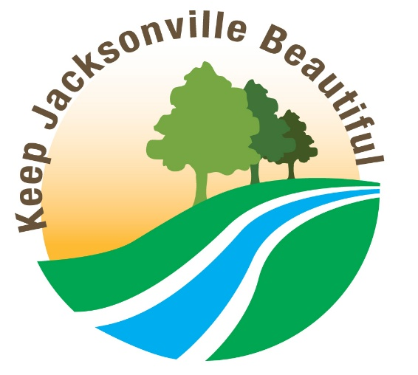

APPLICATIONS FOR 2025 KEEP JACKSONVILLE BEAUTIFUL SCHOOL AWARD

Applicants should have demonstrated an outstanding and ongoing effort in at least two of these areas:

1. Clean Campus
2. Litter/Graffiti Prevention Education
3. Projects
…in a Duval County public or private school.

To apply, please PRINT or TYPE information in all areas of this application, email or mail it to:
kjb@coj.net

Keep Jacksonville Beautiful School Award
Environmental Quality Division
214 N. Hogan St. 5th Floor
Jacksonville, FL 32202
Attention: Dan Durbec

Application deadline: 5 p.m., Friday, October 2, 2026 but may be submitted earlier.

Principal/President’s Name: ________________________________________________________

School:________________________________________________________________________

Mailing Address:_________________________________________________________________

City, State, Zip:__________________________________________________________________

Telephone:____________________________ Best Time to Call:__________________________

E-mail:_________________________________________________________________________

Please attach a summary of the school’s achievements in 2025, along with any supporting documentation as described in the attached guidelines. Summaries must be typed, not handwritten, and e-submissions are encouraged. Once submitted, nominations may not be revised or amended. Keep a copy-- applications and supporting documentation will not be returned to you. Photocopies or digital files of the material on a flash drive are acceptable. The awards will be presented at the annual Environmental Protection Board’s Environmental Achievement Awards luncheon at the University of Florida Nov. 19, 2026. For more information, call 255-8276 or email kjb@coj.net. Awards may be presented in four categories: Elementary, Middle School, High School, and College/University.
Guidelines for Keep Jacksonville Beautiful School Awards

If you’re uncertain about what types of activities are applicable to the three areas to be judged, here are some criteria and examples. Activities should have taken place during 2025, but ongoing projects with elements of sustainability are scored higher than one-time projects. You must include activities in at least two of these three areas and may include all three if you wish. Supplemental material may include photographs, news coverage, letters, commendations, etc.

1. Clean Campus
Summary should describe, in 250 words or less, efforts underway to keep the school campus clean and free of litter, specifically in the areas listed below.
Documentation should show the condition of the school campus in the following areas:
- Main entrance
- Sidewalks
- Playgrounds / sports facilities
- Fenced areas
- Driveways / bus zones
- Lawns / grounds
- Shrubbery / along buildings
- Dumpster area
- Litter containers
Recycling programs in the school’s classrooms, cafeteria, and/or offices are also a consideration.

2. Litter / Graffiti Prevention Education
Summary should list (in 250 words or less) the materials used to educate students, teachers and staff at the school in an attempt to change attitudes toward litter and graffiti and modify behaviors to prevent litter and/or graffiti.
Documentation should show the results of changed attitudes and improved school and community pride resulting from the educational program(s).

3. Projects
Many schools have embarked on ambitious projects to improve their campus environments, with some even branching out to improve their surrounding neighborhoods.
Summary should describe the school’s environmental project(s) in 250 words or less (total, not for each project).
Documentation should show the results of the project(s), with before/after photos, if available.
Examples of the types of projects that would be considered (but don’t limit yourself to these):
- Adopt-A-Road programs
- Participation in organized cleanups such as the St. Johns River Celebration, July 5 Beach Cleanup or the International Coastal Cleanup.
- Waste reduction or recycling programs initiated and managed by students
- Graffiti education and/or litter abatement programs
- Beautification or improvement projects for the campus or surrounding neighborhood, including litter cleanups, painting/repair work, organized plantings, etc.
- Design and production of educational material (printed or electronic) to reach fellow students with anti-litter and anti-graffiti messages, or to demonstrate the links between litter/graffiti and community issues like crime, public health, poverty, etc.
- Activities of environmental clubs that support the anti-litter and anti-graffiti efforts of Keep America Beautiful, promoting pride in school and community and the concept of taking individual responsibility for actions that impact them.

