630-CITY MEDIUM TREE LIST

Eagleston Holly (Ilex x attenuata ‘Eagleston’)
Evergreen (does not drop leaves in winter) 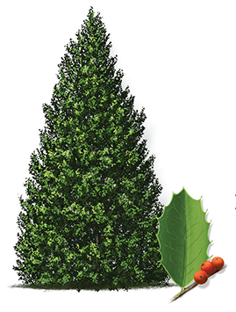
A medium sized tree that is a hybrid between holly species that has a dense, green canopy and produces red berries. Can be in pyramidal form or pruned up with a clear trunk.

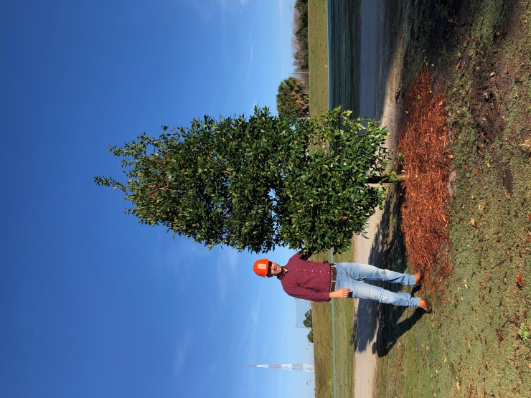

River Birch (Betula nigra)
Deciduous (drops leaves in winter)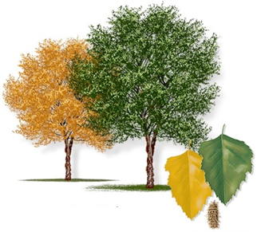
A medium sized tree with very flaky, showy bark that has a very central leader form and sometimes grown in groups of three. Has fall color and non-showy flowers that bloom in mid spring.
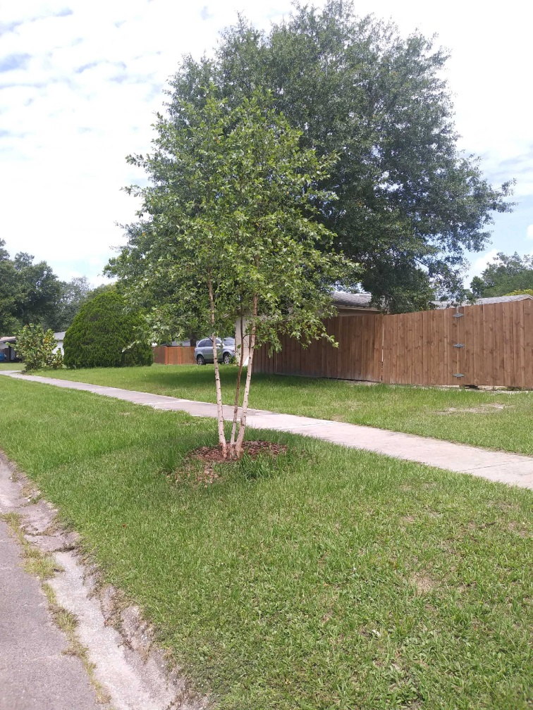

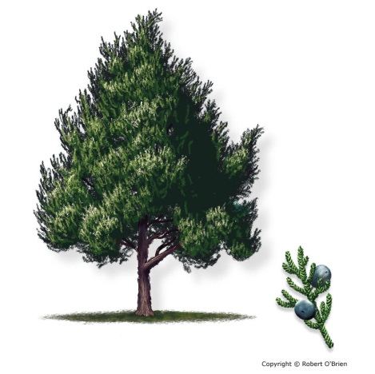
Southern Red Cedar (Juniperus virginana)

Evergreen (does not drop leaves in winter)
A medium sized, slow growing tree that has small scale-like leaves and produces small bluish berries. The cedar has a distinct smell to the wood and a thin reddish bark.

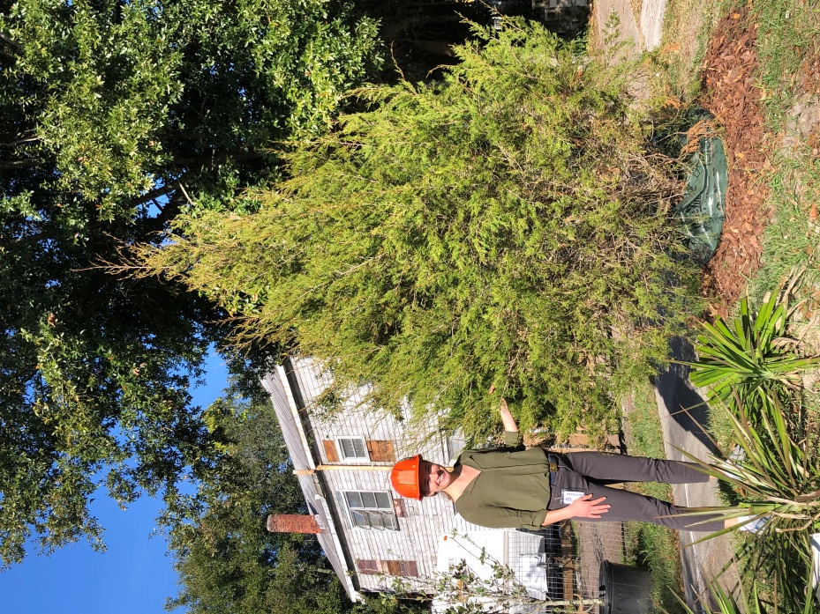

Sweetbay Magnolia (Magnolia virginiana)
Evergreen (does not drop leaves in winter) 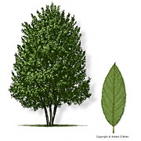
A medium sized magnolia tree that has large green leaves with silvery undersides and produces showy white flowers in the late spring/early summer.

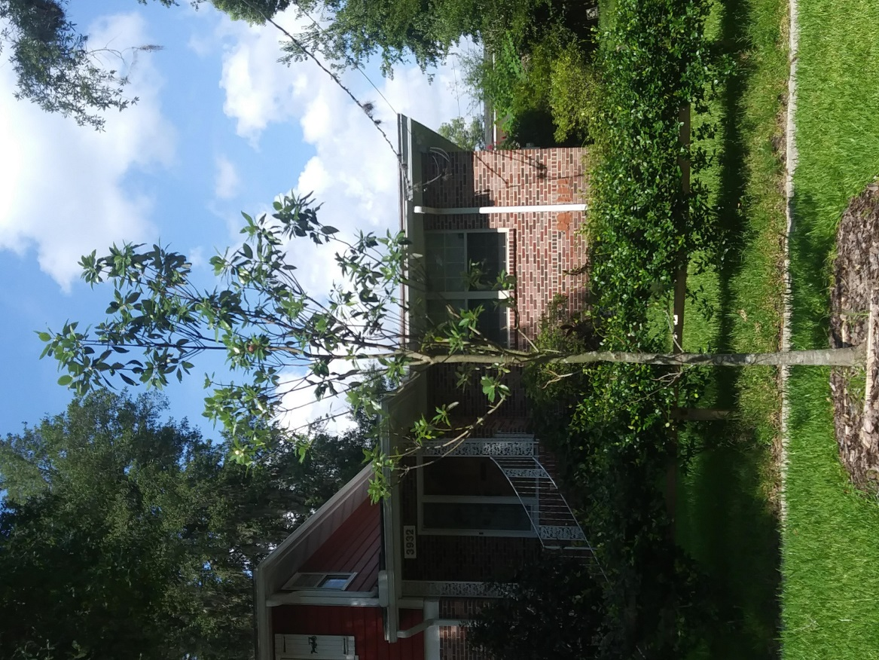

Winged Elm (Ulmus alata)
Deciduous (drops leaves in winter) 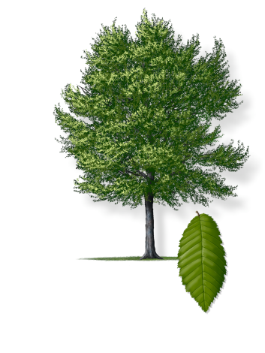
A medium to large tree with green leaves and a distinct ‘winged’ appearance on the branches.
