630-CITY LARGE TREE LIST

Bald Cypress (Taxodium distichum)
Deciduous (drops leaves in winter) 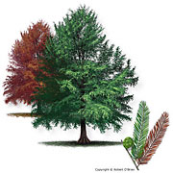
A large sized tree with needles that will turn red/brown in winter that can commonly be seen near water bodies. Can been seen sometimes growing cypress knees and produces small cones.
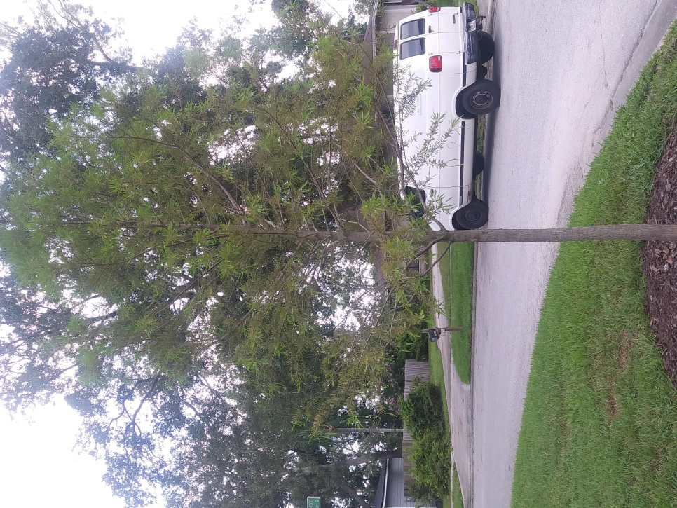

Live Oak (Quercus virginiana)
Evergreen (does not drop leaves in winter)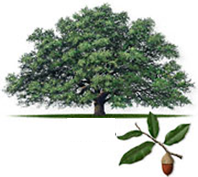
A large sized and wide spreading oak species that can be found across the southeast United States. Adaptable to most sites, this tree can provide a lot of shade at maturity and is a long lived species that can grow quite large.

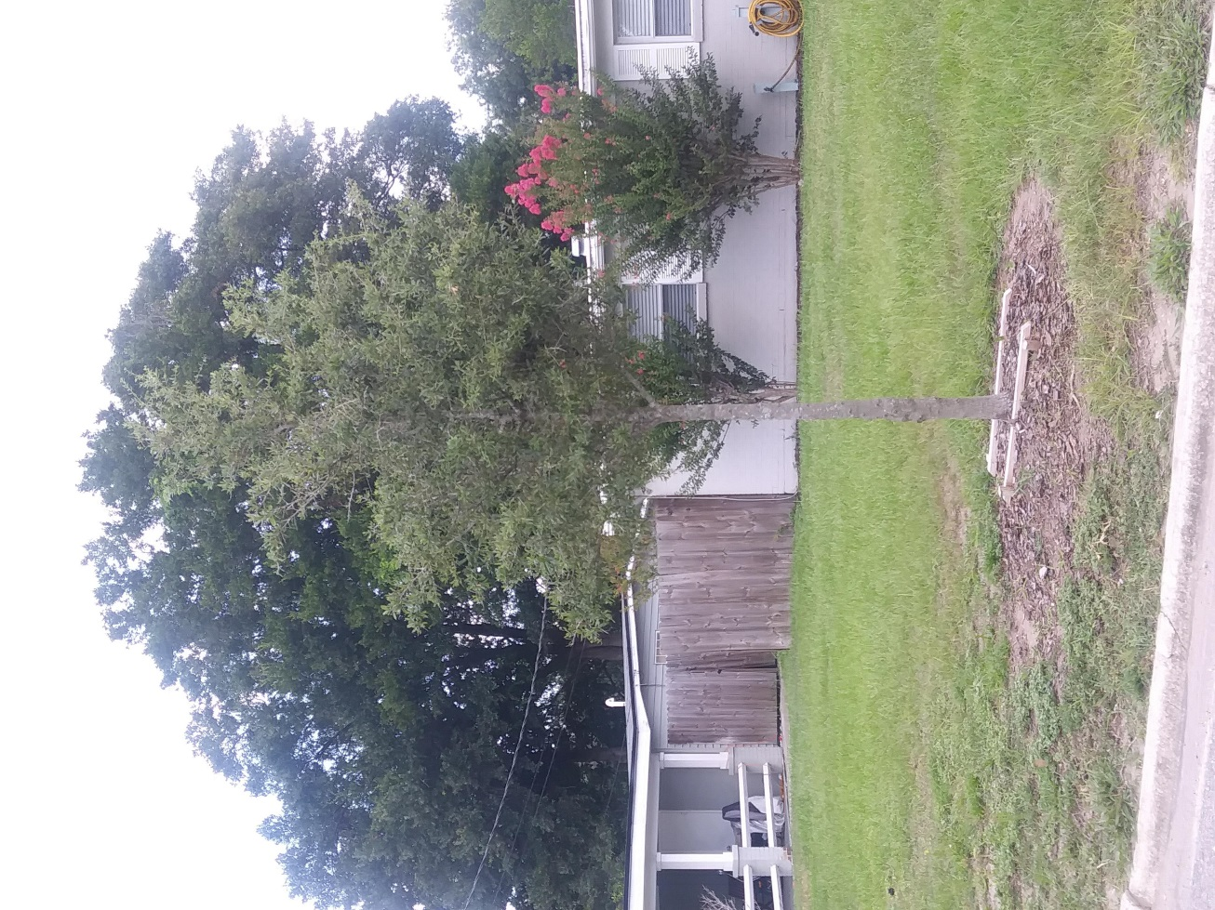

Overcup Oak (Quercus lyrata)
Deciduous (drops leaves in winter)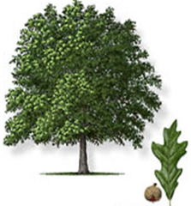
A large sized oak tree species with rounded leaves and a more upright form that can be used for a shade tree.

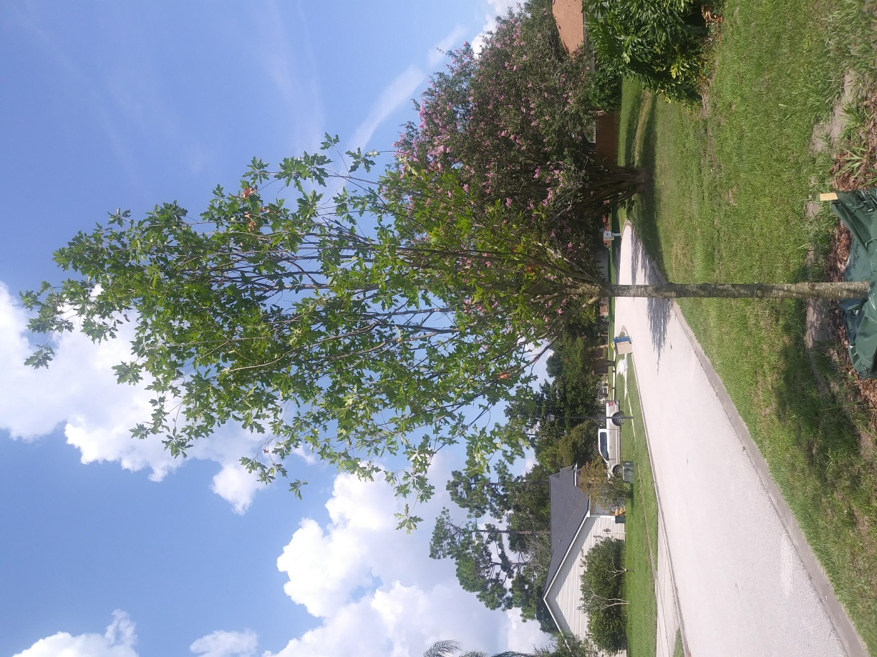

Red Maple (Acer rubrum)
Deciduous (drops leaves in winter)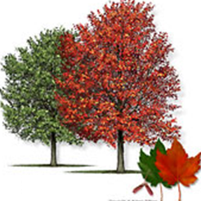
A fast growing, large sized tree with beautiful colors in the fall when the leaves change colors and will drop. It has thin bark and can handle sites that have a little poor draining soil.

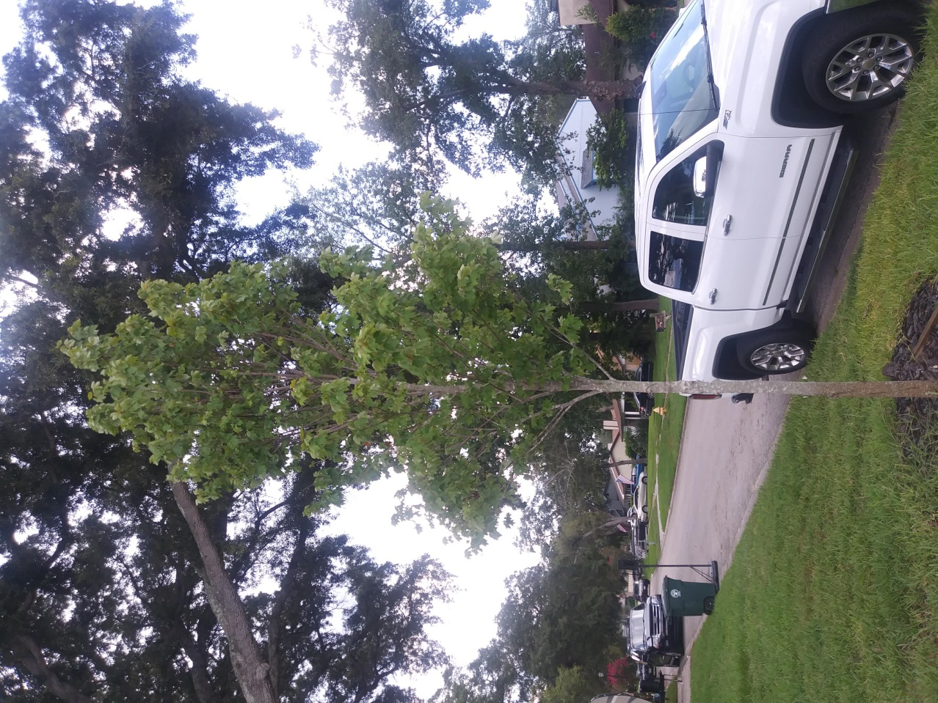

Southern Magnolia (Magnolia grandiflora)
Evergreen (does not drop leaves in winter)**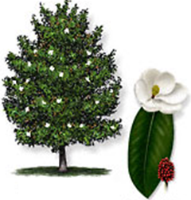
This large tree has large glabrous green leaves with colorful bronze undersides and produces large white flowers. The leaves can drop off and need to be cleaned but all of them do not fall off in the winter. This tree can be quite full and grow quite large produces a lot of shade.
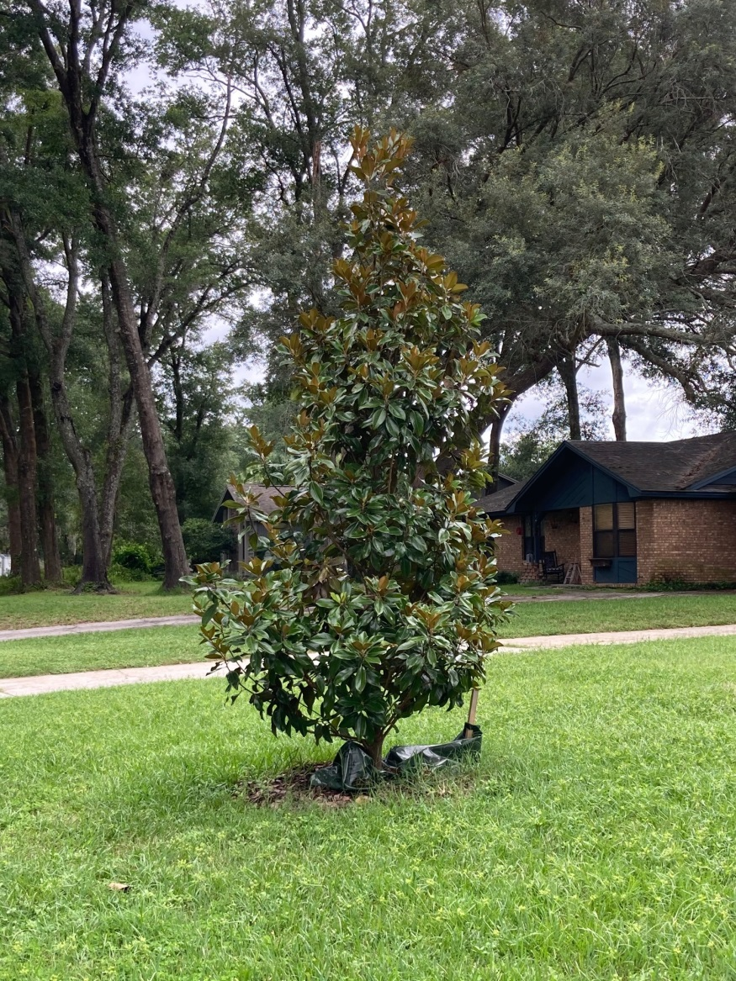

American Sycamore (Platanus occidentalis)
Deciduous (drops leaves in winter)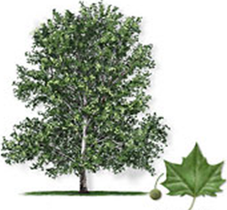
This large, fast growing tree usually has a pyramidal shape and flakey bark. Its wide spreading crown and attractive bark make it a great shade tree. Leaves can me messy when they drop in the fall/winter.
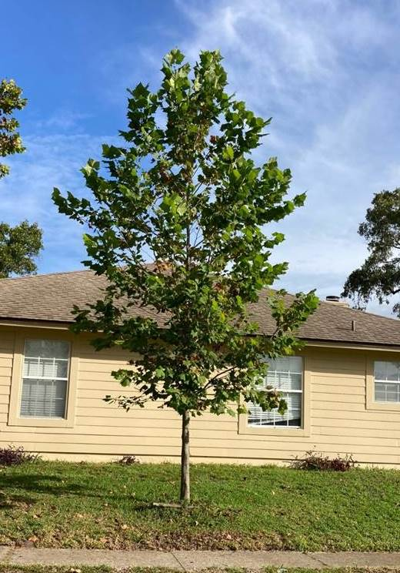

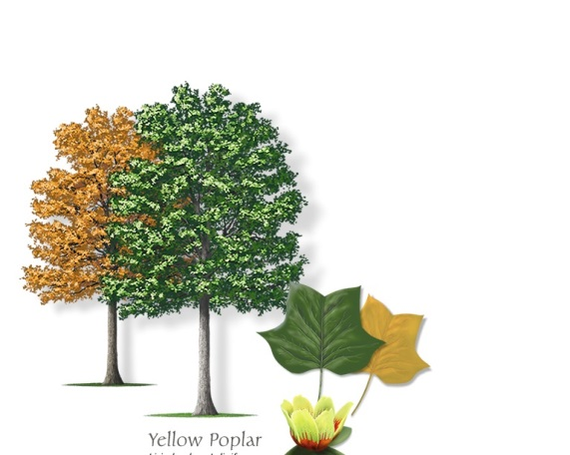
Tulip Poplar – (Liriodendron tulipifera)

Deciduous (drops leaves in winter)
The Tulip Poplar or Tuliptree is a very large species which can grow to over 80’ high and have a very large trunk. Used in only planting locations with a lot of space, this tree has beautiful leaves and can create a lot of shade.
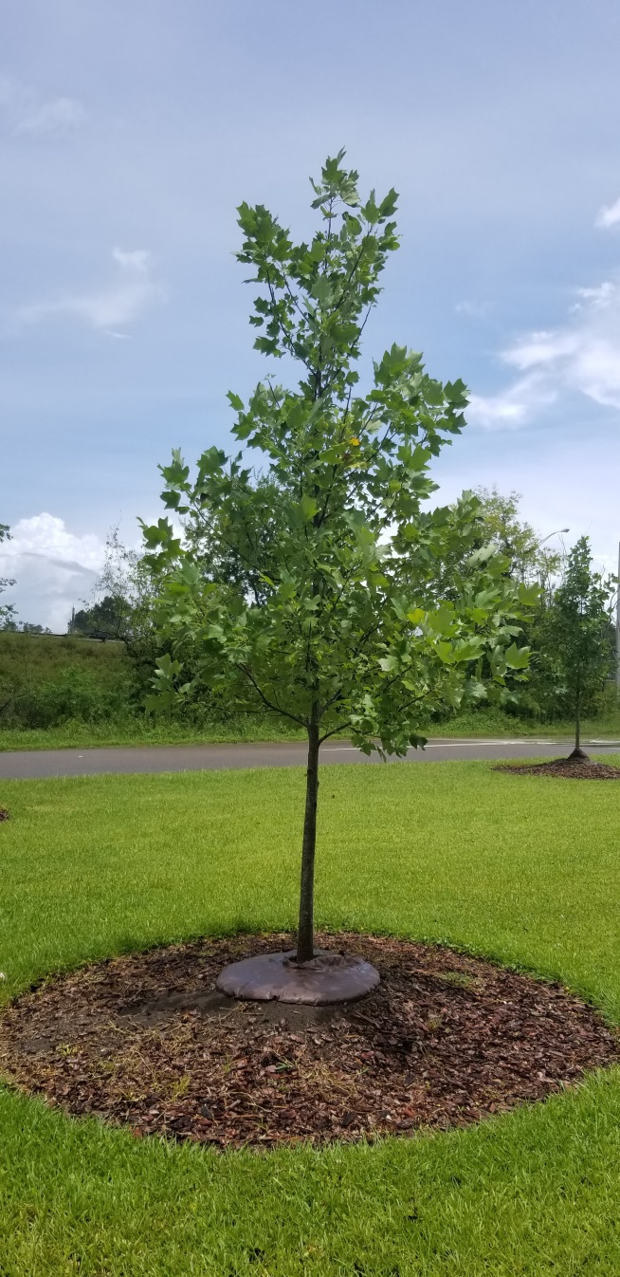

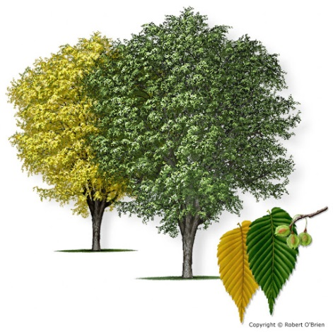
American Elm – (Ulmus americana)

Deciduous (drops leaves in winter)
The American Elm is an iconic tree of the eastern united States. With a vase shaped canopy, this tree can provide shade and fall color.
