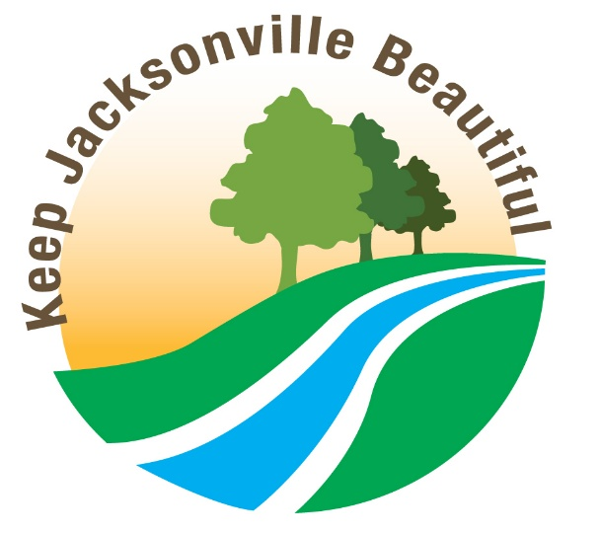

APPLICATIONS FOR 2025 KEEP JACKSONVILLE BEAUTIFUL
ORGANIZATION/BUSINESS/INDIVIDUAL AWARD

Applicants should have demonstrated an outstanding and ongoing effort in 2025 in the area (s) of:

1. Beautification
2. Litter/Graffiti Prevention, and/or
3. Litter Cleanup
in Duval County.

To apply, please PRINT or TYPE information in all areas of this application, email or mail it to:
kjb@coj.net

Keep Jacksonville Beautiful Award
Environmental Quality Division
214 N. Hogan St. 5th Floor
Jacksonville, FL 32202
Attention: Dan Durbec

Application deadline: 5 p.m., Friday, October 2, 2026, but may be submitted earlier.

Applicant’s Name: _______________________________________________________________

Organization/Business: ____________________________________________________________

Mailing Address:_________________________________________________________________

City, State, Zip:__________________________________________________________________

Telephone:____________________________ Best Time to Call:__________________________

E-mail:_________________________________________________________________________

Please attach a summary of the applicant’s 2025 achievements (250 words maximum), along with any supporting documentation, such as photographs, news coverage, letters, etc. Summaries must be typed, and e-submissions are encouraged. Once submitted, applications may not be revised or amended. Keep a copy of your application and supporting documentation. Submissions will not be returned to senders. Photocopies or digital files of the material on a flash drive are acceptable. Awards will be presented at the annual Environmental Protection Board’s Environmental Achievement Awards luncheon at the University of Florida Nov. 19, 2026. For more information, call 255-8276 or email kjb@coj.net. Awards will be presented in three categories: Individual, Business, and Organization.
Guidelines for Keep Jacksonville Beautiful Awards
for Organizations, Businesses and Individuals

If you’re uncertain about what types of activities and projects are applicable to the three areas to be judged, here are some criteria and examples. Activities should have taken place during 2025, but ongoing projects with elements of sustainability are scored higher than one-time projects. Each area is scored for every application, so be sure to list all of your activities.

1. Beautification
In what’s known as the “broken window effect,” blighted properties can be a contributing factor to increased crime in a neighborhood. Individuals, businesses and organizations can help by beautifying their property and surroundings.
Summary should describe, in 250 words or less, efforts that have been made to beautify your property and/or neighborhood.
Documentation may show before and after pictures of the property and surrounding area, including photographs, news coverage, commendations, etc. Examples of good projects would be:
- Use of green building techniques in new structures
- Repair or rehabilitation of blighted facilities
- Xeriscaping of property
- Aesthetic improvement of fencing
- Use of water-permeable paving material in parking lots and/or driveways
- Screening of any dumpsters on your property
- Pedestrian and bicycle-friendly property design
- Inclusion and maintenance of trash cans on property

2. Litter / Graffiti Prevention
In addition to hurting the image of a home, business or organization on whose property it appears, litter and graffiti both contribute to increasing the probability of crime in a neighborhood. But when eliminated quickly after occurrence, the risk decreases.
Summary should list (in 250 words or less) the efforts undertaken to prevent litter and/or graffiti, and to eliminate any that occurs on your property.
Documentation may show before and after photos, removal of litter or graffiti, or educational material developed to reach customers, employees, members, neighbors, etc. on the importance of keeping the area clean and attractive.

3. Litter Cleanup
Many individuals, companies and organizations have embarked on admirable projects to clean up their own properties, with some branching out to remove litter from their surrounding neighborhoods.
Summary should describe your litter cleanup project(s) in 250 words or less.
Documentation should show the results of the project(s), with before/after photos, if available.
Examples of the types of projects that would be considered (but don’t limit yourself to these):
- Adopt-A-Road programs
- Participation in organized cleanups such as the St. Johns River Celebration, July 5 Beach Cleanup, or the International Coastal Cleanup
- Waste reduction or recycling programs
- Regular policing for litter and cleanup of your own property and/or neighborhood.

If you have questions, please call 255-8276. Thank you for participating, and for all your efforts to Keep Jacksonville Beautiful!

