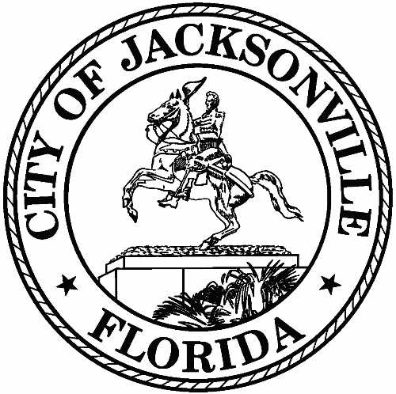
City of Jacksonville
1st Floor - Council Chamber 117 W. Duval Street

Meeting Minutes
Member to Member Meeting

Friday, October 28, 2022
9:00 AM
In-Person Meeting

Safety and Crime Reduction Commission

Meeting Convened: 9:05 am Meeting Adjourned: 10:26 am

Attendance:
Chair: Dr. Constance Hall; Administrator: Dr. Nicoa Garrett

Commissioners: Tom Geismer; Shelley Grant; Ellen Glasser

Liaisons to the Commission: Katoia Wilkins; Stephen Siegel; Harry Wilson; Paul Restivo

Guest: Katie Hathaway; Jennifer Pope; Tanya Washington

Excused: Samuel Newby

- Call to Order
Chair Hall welcomed everyone to the Safety and Crime Reduction Commission (SCRC) to the meeting.
- Roll Call
Quorum
- Remarks – Councilman Newby
Personally thanked everyone for their service. The Safety and Crime Reduction Commission Bill passed. He thanked the commission for their hard work and for making it a smooth process. At one time council members had questions about the process. But, because of the job done (clean, concise, across the board). There will be 43 organizations to receive money to fight crime. I’m here to listen. This is so important to me.
- Approval of the Meeting Minutes
The September 2022 Member to Member meeting summary was approved by the SCRC Commissioners, the quorum was met.
- Administrator Report
Dr. Garrett reported to commissioners Ordinance 2022-0690 was passed October 12, 2022. The original Ordinance changed from 2022-0690 to 2022-0690-E due to substitutes. Dr. Garrett worked with Office of General Counsel (OGC) and presented the SCRC mini grant process to City Council. Dr. Garrett stated 43 organizations will receive funding and the Nonprofit Center of Northeast Florida, Inc. will provide grant training for the nonprofit organizations. Dr. Garrett discussed contract tentative timeline and nonprofit organization expectations for mini grants.

Chairwoman Hall thanked everyone that had a hand in getting the Commission through the mini grant process.

Commissioner Glasser stated “the process was very impressive.”

Councilman Newby stated the process “was airtight and could stand up to PSG.”

Commissioner Gentry commended everyone for this project, “it was fantastic.”

- First Coast Leadership Foundation – Dr. Nahshon Nicks

The mission is to shift our city streets. They service over 290 youth which translate into 290 families. The organization works with them through mentoring and martial arts. They use a holistic approach by establishing communication with the parent, teacher, and principal. The objective is to meet the students where they are, as well as be an adult roll model. This will help students become a better version of themselves.

- MRD Solutions/Transitional Housing Program – Venus Hubbard
The organization assists incarcerated citizens entering back into society with transitional housing. The organization has two houses. They have serviced over 125 males and females with housing (mostly male). They would like to open more doors to assist more women. The organization provides most of the services out of pocket such as clothing, food, transportation, and personal items.

The organization believes that providing shelter to the homeless and reentry population and reduces crime on the streets.

- Targeted Neighborhoods
Paul Restivo with JSO reported that he has shared a quarterly report with mapping with Dr. Garrett which identifies hot spots in specific zones. The report identifies the types of criminal activities, which helps to better allocate resources.

- Vice Chairman Ronnie King
Ellen Glasser reported the intent to solicit councilpersons from the targeted neighborhoods come and present to the SCRC about specific concerns in those neighborhoods, or to have a representative attend a community meeting in one of those areas. There was also suggestion of a targeted survey for certain areas to collect data from teachers, police and local leaders about concerns as well.

There was a discussion of having community events to connect local agencies such as JFRD and area police to have ‘Open House’ type of activities where children can interact and have positive experiences with first responders.

- Subcommittee Reports
Neighborhoods Report – Subcommittee Chair Ronnie King stated it would be good to work with some of the nonprofit with their local initiatives. We need to keep listening to them and combine with other effort to mae sure they are effective. The subcommittee had a great meeting. Chief Restivo provided great maps to help us target our areas as part of the neighborhoods project. We wanr to target one specific area, combine resources, and get feedback from folks living in the area. Chief Restivo provided maps to show problem areas, even as far down as to exact streets. We would like to gather information from neighbors, business, schools, or anyone in the neighborhood to get asset of neighborhoods, such as who are the nonprofits doing great work, places that people feel safe and unsafe.

- Public Comments – 3 Minutes Each

None

With no further business, Chair Hall adjourned the meeting.

Minutes: Nicoa Garrett - Neighborhood Service Office – nicoa@coj.net - 904.255.7532

