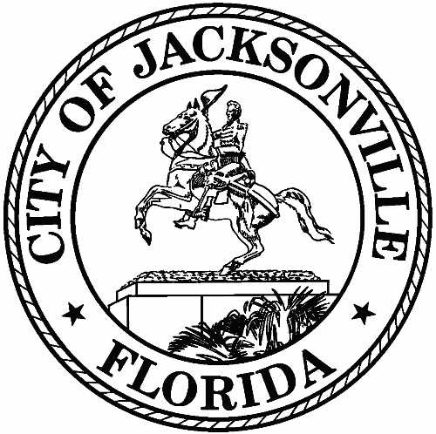
City of Jacksonville
1st Floor - Council Chamber 117 W. Duval Street

Meeting Minutes
Member to Member Meeting

Friday, April 22, 2022
9:00 AM
In-Person Meeting

Safety and Crime Reduction Commission

Meeting Convened: 9:07 am Meeting Adjourned: 10:19 am

Attendance:
Vice Chair: Ronnie King; Administrator: Dr. Nicoa Garrett

Commissioners: Frank Denton; William Gentry; Shelley Grant; Desiree Jones; Ellen Glasser; Vicki Waytowich; Shamika Baker Wright; Tom Geismar

Liaisons to the Commission: City Council President Samuel Newby; Katoia Wilkins; Stephen Siegel; Harry Wilson

Guest: Mike Weinstein; Jessica Denson; Chiquita Moore; Tanya Washington; Andria Bannister; George

- Call to Order –
Vice-Chair Ronnie King welcomed everyone to the Safety and Crime Reduction Commission (SCRC) to the meeting.
- Roll Call –
Quorum Verified
- Remarks
City Council President Samuel Newby thanked the Commissioners that participated at the SCRC Mental Health Bus Stop event located in the Justina Area on Saturday, March 26, 2022. City Council President Newby informed the commissioners that the SCRC Jacksonville Rise Up Grant (sponsored by City Council President Newby and City Council Member Reggie Gaffney) is in a six-week legislative process. City Council President Newby reminded the commissioners that the Jacksonville Rise Up Grant's purpose is to distribute funds to small grassroots organizations throughout the City of Jacksonville whose mission is aligned with the SCRC.
- Approval of Meeting Minutes
The March 2022 SCRC Member to Member meeting summary was approved by the
SCRC Commissioners.
- Administrator Report
Dr. Garrett announced that the next SCRC Mental Health Awareness Campaign event will be held on Saturday, May 21, 2022, at the Philippian Community Church, 7578 New Kings Road. Dr. Garrett reminded the commissioners of the $2.5 million funding recommendations established for the targeted neighborhoods (Eastside, New Town, Durkeeville, Justina, Arlington) that was submitted in November 2021. Dr. Garrett provided a budget review and timeline of the SCRC $1 Million Targeted Neighborhood Project of which $333,333 will be spent per year, over three-year time period. Dr. Garrett provided a budget review and timeline of the SCRC Jacksonville Rise Up Grant ($316,000 will go toward smaller non-profits: $20,000 will go toward for-profit grassroots organizations).

- Targeted Neighborhood Project
Vice-Chair Ronnie King informed the commissioners that all SCRC subcommittee chairs met Wednesday, April 13, 2022, to discuss the MyVillage Project. Vice-Chair King presented a brief overview of the MyVillage Project to the commissioners, demonstrating how the commission can mirror the MyVillage Project to the SCRC Targeted Neighborhood Project. A copy of the presentation was provided to the commissioners.

Vice-Chair Ronnie King provided and explained a suggested plan for the SCRC Targeted Neighborhood Project. A copy of the suggested Targeted Neighborhood Project plan was provided to the commissioners.
- Keeping it in Context-
No Report.
- Subcommittee Update
Vice-Chair Ronnie King instructed each subcommittee to meet over the next two weeks to discuss the suggested Targeted Neighborhood Project plan and bring back suggestions to the full commission for approval. Dr. Garrett will reach out to subcommittees chairs to schedule meeting dates.
- Public Comments – 3 Minutes Each
  - Andria Bannister provided a brief overview of the Resiliency in Communities After Stress and Trauma (ReCAST) services provided in the community.

With no further business, Chair Hall adjourned the meeting.

Summary: Jessica Denson - Neighborhood Service Office – Jcdenson@coj.net - 904.255.8260

