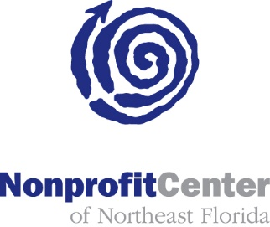

Public Service Grants: Considering the RFP Process
March 2, 2017
Lecture Hall, Jessie Ball duPont Center
3:00 – 4:00 PM
AGENDA

3:00 PM Welcome and Introductions Rena Coughlin
3:10 PM Issue Background: Why RFPs? Dr. Fliger, Vice Chair, PSG Council
3:15 PM RFPs: Dan Pearson, COJ Manager of Procurement
- What is an RFP?
- What is the COJ process for applying, scoring and awarding RFPs?
- What kind of projects/programs/problems are appropriate for RFPs?
- What’s the difference between an RFP and a grant?
3:30 PM Nonprofit Perspective
3:40 PM Open Discussion/ Q & A
3:55 PM Review discussion, capture remaining questions, enumerate and agree on next steps
4:00 PM Adjourn

