JACKSONVILLE HOUSING FINANCE AUTHORITY

Multifamily Mortgage Revenue Bond Program

Application

SUBMIT ORIGINAL (WITH FEES) AND 6 COPIES TO:

Laura Stagner
Director of Finance
Housing and Community Development
214 N. Hogan St., 8th Floor
Jacksonville, Florida 32202

SUBMIT ONE (1) COPY TO:

THE HENDRICKSON COMPANY
1404 ALBAN AVENUE
TALLAHASSEE, FLORIDA 32301
850.671.5601

Revised June 10, 2015

GENERAL INFORMATION

Tax Exempt Bond Amount Requested:$ _

Taxable Bond Amount Requested: $

Total Bond Amount Requested: $ __________________

Total Project Cost: $________________________________________

Development Name:
Note: After Final Board Approval, Development name MAY NOT BE CHANGED OR ALTERED WITHOUT CONSENT OF THE AUTHORITY. If available, provide the actual trade, “marketing” or d/b/a name.

Development Street Address/Zip Code (if new construction, give closest street names, city and zip code): ___________________________________________________________________________

___________________________________________________________________________

___________________________________________________________________________

Legal description is attached behind tab labeled “Exhibit .” The Project must be located in Duval County. (THRESHOLD)

SUMMARY OF PROPOSED DEVELOPMENT

 | NAME OF PROJECT
Developer and
Address (City and State)
Development Location | Name Address Buildings Set-Aside Units Total Units
Type
NC/Rehab
Bedrooms per unit size | _____efficiency _______bedroom _______ 2 bedrooms ____3 bedrooms
Total Square Feet
Bonds Requested
Total and per unit
Total Cost
Cost per unit
Land Cost
Acquisition of Building Cost if applicable
Hard Rehab Cost or Construction Cost
General Contractor
Credit Enhancement if utilizing Bonds
Set Aside Period
Set Aside Levels
Development Design Type | ______ highrise _______ garden ______ quardraplex  ______ mid-rise _______townhouses  ______ other explain)___________________________________

DEVELOPMENT SUMMARY AND TIMELINE

A. Provide a short narrative description of the Development, including all amenities, unit features and scope of work to be performed. MAJOR Development AMENITIES WILL BE INCLUDED IN THE LAND USE RESTRICTION AGREEMENT AND/OR THE LOW INCOME HOUSING AGREEMENT, IF APPLICABLE. Also attach as Exhibit a timeline for the completion of the development which includes all key dates, including anticipated timing of permits and credit underwriting, bond closing date, completion of construction, rent up, and stabilization.

B. TO BE CONSIDERED COMPLETE, the Application must include a map showing the Development’s location, and the location, age, number of units and current occupancy of competing bond and HC developments within a five mile radius (info on age, number of units and occupancy can be shown on chart attached to the map). The map should also include any bond or HC developments within the same radius that are under construction or in credit underwriting either at the Jacksonville Housing Finance Authority and FHFC. Additionally, the map should show the Development’s proximity to community services, medical facilities, schools, shopping, major business and employment centers, and availability of public transportation. This may be found directly behind tab labeled “Exhibit .

C. Applicant must provide a proposed plan for utilizing local, small, and emerging business in the City/County as approved by the City Council for the City of Jacksonville in Chapter 126, Ordinance Code. This may be found directly behind tab labeled “Exhibit ____.
I. APPLICANT INFORMATION

- Applicant Name:

Must be a legally formed entity (i.e., limited partnership, corporation, etc.) qualified to do business in the State of Florida at the time of submission of Application. Include a copy of the certificate of good standing from the Florida Secretary of State. If the Applicant is a general partnership or joint venture, provide a copy of the partnership/joint venture agreement. Documentation can be found behind tab labeled “Exhibit I- ”

Note: If four percent tax credits will be sought and it is contemplated that the tax credits will be syndicated, the Applicant entity must be a limited partnership or a limited liability company at the time of application for the tax credits. The Applicant entity will be the recipient of the tax credits and CANNOT BE CHANGED until after a Final Allocation of tax credits has been issued.

Address:

Telephone: Facsimile:
Email:

- Applicant’s Federal Taxpayer Identification Number: ___________________________________

- If partnership, name of general partner(s):

If corporation, name and title of executive officer:

Address:

Telephone: Facsimile:

- Designated Contact Person: Person with decision making authority with whom the Authority will correspond concerning the Application and Development for Applicant/Borrowing Entity (not a consultant). Who is the Designated Contact Person for this Development?

Relationship to Applicant:

Address:

Telephone: Facsimile:
Email:

- Nonprofit Status

- Is the Applicant a 501(c)(3) non-profit organization pursuant to the Internal Revenue Code?

No Yes If “yes” provide the following items:

  - Attach evidence of non-profit status behind tab labeled “Exhibit I- .”
  - Attach attorney’s opinions as required by the Code behind tab labeled “Exhibit I-____ and
  - Attach evidence that the nonprofit has not exceeded its allocation cap behind tab labeled “ExhibitI-I- .”

II. DEVELOPMENT INFORMATION

Development Location:

- Address: ___________________________________________________________
(if new construction, give closest street names, city and zip code):

- City Council Member District and name of Council Member for this Development’s location: District ____________________________________________________________
Council Member__________________________________________________

Development Category and Population:

1. a. Choose all that apply:

New Construction Acquisition* Remarketing
Rehabilitation Refunding Acquisition/Rehab

- If acquisition, rehabilitation, or acquisition/rehab was selected, is the development occupied?

No Yes
Note: If an acquired Development is occupied, it must be in compliance with program rules at the time of the Bond Closing. Contact the Authority staff immediately for a letter of determination.

c. If acquisition, rehabilitation, or acquisition/rehab was selected, does the project have expiring Section 8 rental assistance contracts or expiring affordable housing land use restrictions?

No ________ Yes ______
Note: If yes, evidence from the appropriate financing entity will be required during credit underwriting

2. Choose the category that describes the population to be served:

Family Elderly Other:

- Has construction begun? No Yes Date permits issued:

Is the development complete? No Yes Date CO issued:

If certificates of occupancy were issued on more than one date, attach a listing of issue-dates for each building directly behind tab labeled “Exhibit II- .”

If not, what is the anticipated placed-in-service date?

- Number of Units:

Total Number of Units (Market rate, Set-aside, and manager units)
Number of Residential Units (Market rate units plus Set-Aside units)
Number of Set-Aside Units:
Percent of Set-Aside Units: (# Set-Aside Units/#Residential Units)

- Manager/Employee Units: Are there one or more manager or employee units in the Development?

No Yes If yes, how many? Unit type(s)

If so, will each unit be occupied by an income-eligible manager/employee and included in the number of units set aside? If included in set-aside, it must be used in all calculations for number of units, e.g. in rent charts, pro formas, etc. NOTE: If manager//employee unit(s) is exempt from HC rent restrictions, the unit rent should be calculated as if it were a market rate unit.
No Yes

- Breakdown of units by square footage and monthly rent charged. All units in the development must be listed INCLUDING all manager/employee units. Indicate manager/employee units with an asterisk.

# of Bedrms/  Unit | # of Baths Per Unit | Square Feet Per Unit | # of Units Per Bedrm type | % of Area Median Income | Monthly Gross Rent for Set-Aside Units* | Less Utility Allowance (for HC Developments) | Net Rent for Set-Aside Units | Monthly Market Rent+
* NOTE: For any Development anticipating the use of tax credits, gross rents include the rent plus the allowance for resident-paid utilities for set-aside units. These rents may not exceed the allowable rents for the chosen set-aside as shown on the applicable rent charts included in the Tax Credit Application Package. Rents will be capped based on set-aside chosen.
+ NOTE: Answer for market rate units only.

- Minimum Set-aside required for Tax Exempt Bond Financing. CHOOSE ONLY ONE:

20% of units at 50% of area median income
40% of units at 60% of area median income

- Development Design. Check the one design that best describes this Development:

Garden Apartments High Rise Mid-Rise with elevator

Townhouses Quadraplexes Other:

- Development Size. Identify acreage or lot size of entire Development:
(NOTE: If Development is a phased Development, include only the acreage for this phase.)

III. PROPOSED DEVELOPMENT FINANCING AND STRUCTURE

A. Proposed Finance Summary (The applicant is required to complete the pro forma found in Attachment 1)

 | Check, if Applicable | Amount | % of Development Cost | $ Per Unit
 |  | $ | % | $
Tax-exempt Bonds* |  | $ | % | $
Tax-exempt Bonds** |  | $ | % | $
Taxable Bonds |  | $ | % | $
Conventional |  | $ | % | $
SAIL (Previous Cycle) |  | $ | % | $
SAIL (Anticipated Funds) |  | $ | % | $
SAIL ELI (Anticipate Funds) |  | $ | % | $
HOME (State Funds)*** |  | $ | % | $
HOME (Local Funds)*** |  | $ | % | $
CDBG*** |  | $ | % | $
SHIP*** |  | $ | % | $
HC Equity (4% credits) |  | $ | % | $
Other (Explain below: |  | $ | % | $
Total |  | $ | % | $

Other:

* Subject to state bond cap pursuant to Section 42(h)(4)(B). IRS, as amended.
** Not subject to the state bond cap pursuant to Section 42(h)(4)(B), IRC, as amended.
*** Explain below whether the funds have been committed, or are being sought in a future funding cycle.

Explanation of SAIL, HOME, CDBG and/or SHIP funding:

If SAIL, HOME, CDBG and/or SHIP funding is shown as already committed, attach a letter from the appropriate governmental entity detailing the commitment, including the dollar amount, source of funding, conditions of funding (including income and/or rent restrictions), whether the funding is a loan or a grant, and if a loan, the interest rate, loan term, amortization, and payback schedule. Attach the letter(s) as “Exhibit III- .”

B. If SAIL, HOME, CDBG and/or SHIP funding is shown and is not firmly committed, attach an explanation of how the development will be completed without those funds. Attach the explanation as “Exhibit III- .

C. If SAIL or HOME funding from Florida Housing is not shown, does the Applicant intend to apply for such funding? If so, how much: $ . What will be the anticipated use of the SAIL or HOME funds if received?

D. Tax Credits. If the Development receives Bond financing, will HC be used? No Yes

1. If yes, HC Requested Amount $

2. If yes, name of Syndicator:
A copy of the Commitment or Letter of Interest for the syndicator including a contact person’s name, address and telephone number; credit underwriting standards; and an outline of proposed rate and terms, must be attached as “Exhibit III- .

A preliminary commitment letter is included as “Exhibit III- ”. The letter must include a description of how the syndication funding will be paid out during construction and following completion. At least 50% of the amount needed to complete construction must be paid at bond closing. A firm commitment letter must be provided during the Credit Underwriting.

E. Rental Assistance. Is development-based rental assistance anticipated for this Development?

No Yes If yes, check all that apply:
Moderate Rehab RD 515
Section 8 Other

Number of units receiving assistance:

Number of years remaining on rental assistance contract:

F. Credit Enhancement

A copy of the Commitment or Letter of Interest for the credit enhancer(s) and/or placement agent, including a contact person’s name, address and telephone number; credit underwriting standards; and an outline of proposed rate and terms, must be attached as “Exhibit III- .

- 50% Bond Test: For purposes of meeting the 50% bond test to receive automatic HC, tax-exempt bonds represent %. Attach a detailed 50% test calculation as Exhibit IV- .

- Proposed Structure. The outline of the proposed structure must include, at a minimum, the following: whether a combination of tax-exempt and taxable bond financing expected, whether a fixed or floating interest rate is expected, mortgage term, amortization schedule, interest terms, description of the credit enhancement or placement structure, and additional financing or equity sources. Material changes in the proposed structure after submittal of the application may result in delay of consideration by the Authority or loss of priority. A description of the proposed financing structure is attached as “Exhibit III- .”

- Economic Feasibility of the Development. A description of the Development feasibility structure must be attached as “Exhibit III- ” and include, at a minimum, the following:

  - 15-year Pro forma cash flow
  - Maximum interest rate at which the Development will work
  - Detailed sources and uses, including a breakout for each line item on a per unit cost basis.

IV. PUBLIC POLICY ISSUES

- The Applicant agrees to abide by the set-asides described in this application for years with a minimum of 50 years.

- Applicant must agree to participate in the Crime Free Multi-Housing Program sponsored by the Jacksonville Sheriff’s Office. Terms of this program are included as Attachment 2. Proof of participation must be provided to the Authority semi-annually.

3. Describe in detail all resident programs and activities that will be provided by the Applicant. Each program mandated by the Authority or selected by the Applicant will be made a part of the Land Use Restriction Agreement, and must be described behind tab labeled “Exhibit IV- .” Developments that include a mix of elderly and non-elderly units must provide all resident programs mandated for both elderly and non-elderly developments. The resident programs to be provided are:

- Resident programs for All Applicants:

Health Care – Mandatory - Regularly scheduled visits by health care professionals such as nurses, doctors, or other licensed care providers. At a minimum, the following services must be provided at no cost to the resident: health screening, flu shots, vision and hearing tests. Regularly scheduled is defined as not less often than once each quarter. On-site space must be provided.

Resident Activities – Mandatory - Regularly scheduled, specified activities, planned, arranged, managed, and paid for by the Applicant or its management agent as an integral part of the management plan. The Applicant must develop and execute a comprehensive plan of varied activities such as holiday or special occasion parties, community picnics or cookouts, newsletters, children’s special functions, etc., to bring the resident together, foster a sense of community, and encourage community pride.

On Site Voter Registration – Mandatory – The Applicant or its Management Agent shall work with the County Supervisor of Elections to arrange on-site voter registration. The registration shall be at least quarterly, and shall be during weekend and other traditionally non-work times.

Swimming Lessons – Optional – The Applicant or its Management Agent shall provide on-site swimming lessons for children or adults, at no cost to the resident, at least three times each year.

Life Safety Training – Optional – The Applicant or its Management Agent shall provide on-site courses such as fire safety, first aid (including CPR), etc. at least twice each year, at no cost to the resident.

Health and Nutrition Classes – Optional – The Applicant or its Management Agent shall provide on-site classes, at no cost to the resident, at least 8 hours per year.

Day Care – Optional – either:

Day care facility for children or adults on-site, or

A discount of at least 20% at a day care facility for children or adults within 3 miles of the development.

Case Management/Residential Stabilization/Services – Optional – This service must be provided by a qualified social worker at no cost to the resident. This program requires that the following services be made available on-site no less often than once a week: crisis intervention, individual and family needs assessment, problem solving and planning, appropriate information and referral to community resources and services based on need, monitoring of ongoing ability to retain self-sufficiency, and advocacy to assist clients in securing needed resources.

- Residential Programs for Elderly Developments:

Resident Assurance Check-In Program – Mandatory – Applicant must provide and use an established system for checking in with each resident on a predetermined basis not less than once per day. Residents may opt out of this program with a written certification that they chose not to participate.

Daily Activities – Mandatory – Applicant or its Management Agent must provide supervised, structured activities at least five days per week. Activities must be on-site and at no charge to the residents.

Meals – Optional – Applicant must pay for daily, at least one meal per day, delivery and cost of meals to the residents or provide for the daily preparation and serving of meals in a designated common on-site facility. Programs such as “Meals on Wheels” will not qualify for points because Applicant is not providing the service.

Applicant will provide for delivery and cost of daily meals (at least one meal per day) to be served in a designated common facility located on-site; or

Applicant will arrange for daily meals, at least one meal per day, to be delivered to the residents at no cost to the residents.

Private Transportation for the Development – Optional – The Applicant or its Management Agent, at no cost to the resident, must provide a qualified driver and have a safe and serviceable vehicle that can transport residents to off-site locations for such things as medical appointments, public service facilities, and/or educational or social activities. A nearby bus stop or access to programs such as “Dial a Ride” will not be acceptable for purposes of this commitment.

Assistance with Light Housekeeping, Shopping and/or Laundry – Optional – Applicant must provide weekly assistance with at least two of the following: (1) light housekeeping, and/or (2) grocery shopping, and/or (3) laundry, at a rate which is at least 25% lower than market.

Manager On-Call 24 Hours Per Day – Optional – Applicant must provide a manager and/or security guard on the Development’s premise at all times who is available and accessible to the residents 24 hours per day, seven days per week.

- Resident Programs for Non-Elderly Developments:

Homeownership Opportunity Program – Mandatory – Applicant must provide a homeownership opportunity program available to all residents in compliance with their current lease. The program must set aside 5% of the resident’s gross rent toward a downpayment for that resident when the resident moves from the development into homeownership. The resident may be suspended from the program during the period of a lease if the resident violates any provision of the lease. Upon renewal of the lease, the resident must be reinstated into the program for the period of that renewal, with suspension permitted under the same terms as discussed above. The homeownership opportunity program must also include financial counseling for all residents, with emphasis on credit counseling and other items necessary for successful purchase of, and maintenance of a home.

First Time Homebuyer Seminars – Mandatory – Applicant must arrange for and provide at no cost to the resident, in conjunction with local realtors or lending institutions, semiannual on-site seminars for residents interested in becoming homeowners.

After School Program for Children – Optional – Applicant or its Management Agent must provide daily, supervised, structured, age-appropriate activities for children during the after-school hours. Activities must be on-site and at no charge to the residents.

Literacy Training – Optional – Applicant must make available, at no cost to the resident, a literacy tutor(s) to provide weekly literacy lessons to residents in private space on-site and must include English as a Second Language lessons to residents in private space on-site

Job Training – Optional – Applicant must provide, at no cost to the resident, regularly scheduled classes in typing, computer literacy, secretarial skills or other useful job skills. Regularly scheduled means not less often than once each quarter.

4. Describe in detail all design and other physical amenities that provide enhanced quality of life, energy efficiency, increased security, handicapped accessibility, or other features. Each feature mandated by the Authority or selected by the Applicant will be made a part of the Land Use Restriction Agreement, Developments that include a mix of elderly and non-elderly units must provide design features for both elderly and non-elderly units must provide design features for both elderly and non-elderly developments. The design and amenity features to be provided are:

- In addition to meeting all building code, Fair Housing Act, and Americans with Disabilities Act Requirements, the following items are required:

- Air conditioning (window units are not allowed), in all units
- Dishwasher, in all new construction units
- Garbage Disposal, in all new construction units
- Cable TV Hook-Up, in all units
- At least two full bathrooms in all 3 bedroom or larger new construction units
- At least 1 and ½ bathrooms (one full bath and one with at least a toilet and sink) in all new construction 2 bedroom units
- Minimum square footage requirements for all new construction units of 600 square feet (one bedroom), 850 square feet (two bedroom), 1050 square feet (three bedroom), and 1200 square feet (four bedroom or greater)
- Full sized appliances in all units
- Bathtub in at least one bathroom in new construction non-elderly units
- Exterior Lighting for all buildings and parking areas
- Window Treatments (mini-blinds, curtains, vertical blinds) inside each unit- identify treatment

b. For New Construction Units, the applicant may select items from the following list. The selected items must total 25 points:

30 Year Expected Life Roofing on all Buildings (5 points)

Gated community with “carded” entry or security guard, of if mid-or-high-rise, “carded” secure entry to building (4 points)

Ceramic tile Bathroom Floors (2 points)

Microwave Oven (3 points)

Marble Window Sills (3 points)

Fire Sprinklers in All Units (5 points)

Steel entry door frames (2 points)

Termite prevention/detection system (2 points)

Built-in computer desks (2 points)

Exterior lighting (3 points)

Double compartment kitchen sink (1 point)

Laundry Hook-ups and space for washer/dryer inside each unit (3 points)

c. For Rehabilitation of Existing Development, the applicant may select items from the following list. The selected items must total 25 points:

Laundry Hook-ups and space for washer/dryer inside each unit (3 Points)

30-Year Expected Life Roofing on all Buildings (4 points)

Gated community with “carded” entry or security guard, or if mid-or-high rise, “carded” secure entry to building (3 points)

Ceramic Tile Bathroom Floors (2 points)

Microwave Oven (3 points)

Fire Sprinklers in All Units (4 points)

Dishwasher inside each unit (3 points)

Garbage disposals inside each unit (3 points)

Steel entry door frames (2 points)

Termite prevention/detection system (2 points)

Double compartment kitchen sink (1 point)

- For Elderly Developments or developments with elderly units, the applicant may select from the following list. The selected items must be on-site and total 16 points (2 points each):

Emergency call service in all elderly units
Hairdresser Shop or Barber Shop on site
Laundry facilities available on every floor
All bathrooms in elderly units handicapped accessible with grab-bars per ANSI requirements
Public transportation within 150 feet of property (or elderly building if mixed family-elderly)
Exercise room with appropriate equipment
Community center or clubhouse
Swimming pool
Covered picnic area with at least three permanent picnic tables and a permanent outdoor grill
Outside recreation facility (such as shuffleboard court, putting green, tennis court). Identify facility:
Library consisting of a minimum of 100 books and 5 magazine subscriptions. The Library must include a computer lab.
Garden Area (must be sized in proportion to development’s size and expected resident population)

- For Non-Elderly Developments, or developments with non-elderly units, the applicant may select from the following list. The selected items must be on-site and total 16 points (2 points each):

Exercise room with appropriate equipment
Community center or clubhouse
Swimming pool
Playground/tot lot (must be sized in proportion to development’s size and expected resident population with age-appropriate equipment
Car care area (for car cleaning/washing)
Childcare facility located within three miles of the property
Public transportation located within one-half mile of the property
Library/study room consisting of a minimum of 100 books and 5 magazine subscriptions. The Library must include a computer lab.
Two or more parking spaces per unit
Outside recreation area for older children (such as basketball court, tennis court, volleyball court, etc.). Identify facility:
.

- Energy Conservation Feature – For all developments, the applicant may select from the following list.

Mandatory Features:
    - Energy Star qualified refrigerator;
    - Energy Star qualified dishwasher;
    - Energy Star qualified washing machine, if provided by applicant;
    - Minimum SEER of 14 for unit air conditioners (excluding buildings with a central chiller system);
    - Caulk, weather strips, seal holes, cracks, etc. (Rehab developments)
    - Sealed and insulated heating and cooling system ducts (Rehab developments)
    - Low-VOC paint for all interior walls (50 grams per liter or less for flat paint; 150 grams per liter or less for non-flat paint);
    - Low-flow water fixtures in bathrooms--WaterSense labeled products or the following specifications:
      - Toilets: 1.6 gallons/flush or less
      - Faucets: 1.5 gallons/minute or less
      - Showerheads: 2.2 gallons/minute or less.
    - Programmable thermostat in each unit

Optional Green Building Features:
Applicant must choose at least five (5) items from the following list:
- Energy Star ceiling fans in all bedrooms and living areas
    - Energy Star qualified roofing material or coating
    - Energy Star exhaust fans in bathrooms
    - Energy Star rating for all windows
    - Install daylight sensors, timers or motion detectors on all outdoor lighting attached to buildings
    - FL Yards and Neighborhoods certification on all landscaping
    - Eco-friendly flooring -- Carpet and Rug Institute Green Label certified carpet and pad, bamboo, cork, recycled content tile, and/or natural linoleum
    - Eco-friendly cabinets – formaldehyde free, material certified by the Forest Stewardship Council
.

v. ABILITY TO PROCEED

Each Application shall be reviewed for feasibility and ability of the Applicant to proceed with construction of the Development.

A. Site Control

Site Control must be demonstrated by the APPLICANT. At a minimum, a Contract for Purchase and Sale must be held by the Applicant for the proposed site. The contract may not expire before 7 months from date the Bond Application was submitted to JHFA and the remedy for default on the part of the seller must include or be specific performance, and the buyer MUST be the Applicant. Site is controlled by:

Contract for Purchase & Sale,

Recorded Deed,

Long-Term Lease: If site control is demonstrated by long-term lease, a copy of the executed lease must be provided. The lease may be contingent only upon the receipt of Bond Financing

IMPORTANT: If site control is not held by the Applicant, a fully executed, enforceable contract for purchase and sale or assignment of contract must be provided which obligates the seller or assignor to transfer the site to the Applicant contingent ONLY upon the award of Bond Financing. If site control is evidenced by contract for purchase and sale, the Authority may give preference to those contracts that evidence ability to extend through December 31, (after the initial 7 month site control requirement). Evidence of Site Control can be found directly behind tab labeled “Exhibit V- .”

B. Zoning and Land Development Regulations

1. a. Is the site appropriately zoned for the proposed Development: No Yes

b. Indicate zoning designation (s)

c. Current zoning permits units per acre, or for the site (PUD).

d. Total Number of Units in Development:

Note: at a minimum, the current, applicable Future Land Use Map Designation and associated Local Government Comprehensive Plan Future Land Use Element provisions must permit the proposed Development.

2. New Construction Zoning and Land Development Regulation Development Requirements:

- Applicant must provide a letter from the appropriate local government official that the Development is consistent with zoning and land development regulations, which verify that the site is appropriately zoned and consistent with local land use regulations regarding density and intended use. To meet minimum requirements, attach a letter from the appropriate local government official verifying that the current, applicable Future Land Use Map Designation and associated Local Government Comprehensive Plan Future Land Use Element provisions permit the proposed Development. The local government verification letter can be found directly behind tab labeled “Exhibit V- ”

3. Rehabilitation Zoning and Land Development Regulation Development Requirements:

Applicant must provide a letter from the appropriate local government official that the Development is consistent with zoning and land development regulations, which verifies that the site is appropriately zoned and consistent with local land use regulations regarding density and intended use. To meet minimum requirements, attach a letter from the appropriate local government official verifying that the current, applicable Future Land Use Map Designation and associated Local Government Comprehensive Plan Future Land Use Element provisions permit the proposed Development. The local government verification letter can be found directly behind tab labeled “Exhibit V- .”;

4. Site Plan

- New Construction: Evidence must be provided on the status of Site Plan approval. To meet minimum requirements, attach a letter from the appropriate local government official verifying the status of Site Plan approval. The letter must be development specific and must state if Site Plan has been approved or if the plan has been through a conceptual or preliminary review. Evidence is attached as “Exhibit V- .”

- Rehabilitation: Was site plan approval required by local governmental authorities at the time this Development was originally placed in service?

Yes No

A COPY OF THE SITE PLAN OR “AS BUILT” SURVEY WILL BE REQUIRED PRIOR TO BEING INVITED INTO CREDIT UNDERWRITING

D. Environmental Safety:

A COPY OF A PHASE I ENVIRONMENTAL REPORT AND IF REQUIRED A PHASE II AND REMEDIAL ACTION REPORT WILL BE REQUIRED DURING CREDIT UNDERWRITING

E. Concurrency. Attach a letter or letters from the local government or provider verifying availability of infrastructure and capacity for the proposed Development. Letters must be Development-specific and dated within 3 months of the date of the Application.

Electricity Exhibit V-
Water Exhibit V-
Sewer capacity, Package Treatment, or Septic Tank Exhibit V-
Roads Exhibit V-

F. Experience of the Development Team-

The past performance record of the development team (which consists of Developer, Management Agent, General Contractor, Architect/Engineer, Attorney, and Accountant) will be carefully reviewed. IF THERE ARE ANY MEMBERS OF THE TEAM THAT WERE A PART OF THE TEAM ON A JHFA BOND TRANSACTION THAT CLOSED IN THE LAST TWO YEARS, YOU ONLY NEED TO COMPLETE THE INFORMATION ASKED BELOW FOR EACH MEMBER THAT MEETS THIS REQUIREMENT AND AN EXPERIENCE CHART DOES NOT NEED TO BE PROVIDED.

1. Experience of Developer: Name:
Principal(s):

  - Provide the Experience Chart as Exhibit V - ________.

  - Has the Developer, or any of the principals of the Developer been associated with any development that has gone into default or given “troubled development” status?
Yes No
If “Yes”, attach a detailed explanation of the situation(s) and resolution as “Exhibit V- .”

c. Has the Developer or any principal of the Developer been associated with any development that has been found in non-compliance with program requirements; i.e. an incurred 8823?
Yes No
If “Yes”, attach a detailed explanation of the situation(s) and resolution as “Exhibit V- .”

2. Experience of General Partner. Name:
If entity, name of principal(s):

  - Fill out the attached chart. Provide the Experience Chart as Exhibit V - ________.

  - Has the General Partner, or any of the principals of the General Partner been associated with any development that has gone into default or given “troubled development” status?
Yes No
If “Yes”, attach a detailed explanation of the situation(s) and resolution as “Exhibit V- .”

  - Has the General Partner or any principal of the General Partner been associated with any development that has been found in non-compliance with program requirements?

Yes No
If “Yes”, attach a detailed explanation of the situation(s) and resolution as “Exhibit V- .”

3. Experience of Management Agent. Name:
Principal(s):

- Fill out the attached chart and provide as “Exhibit V-_____”

- Has the Management Agent, or any of the principals of the Management Agent been associated with any development that has gone into default or given “troubled development” status?
Yes No
If “Yes”, attach a detailed explanation of the situation(s) and resolution as “Exhibit V-. ”

c. Has the Management Agent or any principal of the Management Agent been associated with any development that has been found in non-compliance with program requirements; ?
Yes No
If “Yes”, attach a detailed explanation of the situation(s) and resolution as “Exhibit V- .”

4. Experience of General Contractor. Name: _______________________

- Fill out the attached chart and provide as “Exhibit V-_____”

5. Experience of Architect. Name: ________________________________________

a. Fill out the appropriate attached chart and provide as “Exhibit V-_____”

6. Experience of Engineer. Firm Name: _______________________________

a. Fill out the appropriate attached chart and provide as “Exhibit V-_____”

7. Experience of Attorney. Name: ______________________________________

a. Fill out the attached chart and provide as “Exhibit V-_____”

8. Experience of Accountant. Name: _____________________________________

a. Fill out the attached chart and provide as “Exhibit V-_____”

EXPERIENCE OF DEVELOPER

Name: __________________________________________________________
Address: _____________________________________________________
Phone Number: Contact Email:

Development Name | Location (City, State) | # of Units | New Construc. Or Rehab | Design Type | Sources of Financing/Gov’t. Programs (Bonds/9% HC/SAIL/HOME/  SHIP/Conventional, etc.

The Applicant must provide, as Exhibit V - _______, a prior experience chart for each Principal intending to meet the Developer Experience reflecting the required information listed in chart above.

EXPERIENCE OF GENERAL PARTNER

Name: ____________________________________________________________
Address: ______________________________________________________
Phone Number: Contact Email:

Development Name | Location (City, State) | # of Units | New Construc. Or Rehab | Design Type | Sources of Financing/Gov’t. Programs (Bonds/9% HC/SAIL/HOME/  SHIP/Conventional, etc.

The Applicant must provide, as Exhibit V - _______, a prior experience chart for each Principal intending to meet the General Partner Experience reflecting the required information listed in chart above.

EXPERIENCE OF MANAGEMENT AGENT

Name:
Address:
Phone Number: Contact Email:

Development Name | Location (City, State) | # of Units | Management Status  (current or  former) | # of Years Managed | Sources of Financing/Gov’t. Programs (Bonds/9% HC/SAIL/HOME/  SHIP/Conventional, etc.

The Applicant must provide, as Exhibit V - _______, a prior experience chart for the Management Agent reflecting the required information listed in chart above.

EXPERIENCE OF GENERAL CONTRACTOR

Company Name:
Address
License Number: Expiration Date:
Contact Name: Phone Number: Email:

Development Name | Location (City, State) | # of Units | New Construc. Or Rehab | Design Type | Year Completed

The Applicant must provide, as Exhibit V - _______, a prior experience chart for the General Contractor the reflecting required information listed in chart above.

EXPERIENCE OF ARCHITECT

Company Name:
Address
License Number: Expiration Date:
Contact Name: Phone Number: Email:

Development Name | Location (City, State) | # of Units | New Construc. Or Rehab | Design Type | Year Completed

The Applicant must provide, as Exhibit V - _______, a prior experience chart for the Architect reflecting the required information listed in chart above.

EXPERIENCE OF GENERAL ENGINEER

Company Name:
Address
License Number: Expiration Date:
Contact Name: Phone Number: Email:

Development Name | Location (City, State) | # of Units | New Construc. Or Rehab | Design Type | Year Completed

The Applicant must provide, as Exhibit V - _______, a prior experience chart for the General Engineer reflecting the required information listed in chart above.

EXPERIENCE OF ATTORNEY

Name of Firm:
Name of Attorney(s):
Address of Attorney:
Phone Number: Email:

Development Name | Location  (City, State) | Role (Bond, Real Estate, Other) | Sources of Financing/Gov’t. Programs (Bonds/9% HC/SAIL/HOME/  SHIP/Conventional, etc. | If Bonds, Name of Issuer

The Applicant must provide, as Exhibit V - _______, a prior experience chart for the Attorney reflecting the required information listed in chart above.

EXPERIENCE OF ACCOUNTANT

Firm Name:
Address:
Contact Name: Phone Number: Email:

Development Name | Location  (City, State) | Sources of Financing/Gov’t. Programs (Bonds/9% HC/SAIL/HOME/  SHIP/Conventional, etc. | If Bonds, Name of Issuer

The Applicant must provide, as Exhibit V - _______, a prior experience chart for the Accountant reflecting the required information listed in chart above.

VI. FORM OF EXPENSE AND INDEMNITY AGREEMENT

Attach as Exhibit VI-____ the “Form of Expense and Indemnity agreement found as Attachment 3 of the Application Exhibit B within the “Application Procedures and Program Guidelines” handbook. An ORIGINAL SIGNATURE must be included on the form contained within the original application. Photocopies of the executed form may be utilized within the 11 copies of the application.

VII. REHABILITATION APPLICANTS ONLY SECTION

Attach as Exhibit VII-___, a detailed description of the rehabilitation activities and the status and plans for existing residents. At a minimum, the attachment should describe (i) a detail of all rehabilitation, including the rehabilitation cost per unit and the cost for each item, (ii) the current rents at the development compared to the proposed rents, (iii) the plans for the existing residents, both during and after rehabilitation, (iv) the income levels of the current residents, and whether the current residents will qualify as residents after rehabilitation, (v) a copy of any third party physical needs assessment, or explanation for why the document is not available.

VIII. CERTIFICATION (Original Signatures Required)

The undersigned Applicant certifies that the information in this Application is true, correct and authentic.

THE APPLICANT FURTHER ACKNOWLEDGES HAVING REAL ALL APPLICABLE AUTHROITY RULES GOVERNING THE PROGRAM AND ACKNOWLEDGE HAVING READ THE INSTRUCTIONS FOR COMPLETING THIS APPLICATION.

THE APPLICANT ACKNOWLEDGES HAVING READ ALL PROVISIONS OF THE JACKSONVILLE HOUSING FINANCE AUTHORITY 2016 MULTIFAMILY BOND ALLOCATION POLICIES AND PROCEDURES AND PROGRAM GUIDELINES HANDBOOK.

THE APPLICANT UNDERSTANDS AND AGREES TO ABIDE BY THE PROVISIONS OF THE APPLICABLE FLORIDA STATUTES AND AUTHORITY PROGRAM POLICIES, RULES AND GUIDELINES.

THE UNDERSIGNED REPRESENTS AND WARRANTS THAT THE INFORMATION PROVIDED HEREIN IS TRUE AND ACCURATE. THE PERSON EXECUTING THIS DOCUMENT REPRESNTS THAT HE OR SHE HAS THE AUTHORITY TO BIND THE APPLICANT AND ALL INDIVIDUALS AND ENTITIES NAMED HEREIN TO THIS WARRANTY OF TRUTHFULNESS AND COMPLETENESS OF THE APPLICATION.

THE APPLICANT ACKNOWLEDGES THAT THE AUTHORITY’S INVITATION TO SUBMIT AN APPLICATION DOES NOT CONSTITUTE A COMMITMENT TO FINANCE THE PROPOSED DEVELOPMENT. BEFORE THE AUTHORITY CAN APPROVE THE PROPOSED DEVELOPMENT FOR FINANCING, IT MUST RECEIVE STATE BOND ALLOCATION AND APPLICANTS MUST SUCCESSFULLY COMPLETE CREDIT UNDERWRITING AND OBTAIN ALL NECESSARY APROVALS FROM THE BOARD OF DIRECTORS, AUTHORITY COUNSEL, BOND COUNSEL, THE CREDIT UNDERWRITER AND COUNY COMMISSION AND STAFF.

Applicant Date
Signature of Witness

Name and Title ((typed or printed) Name (typed or printed)

NOTE: ORIGINAL APPLICATION MUST CONTAIN AN ORIGINAL SIGNATURE PENNED IN BLUE INK, OR THE APPLICATION WILL BE REJECTED AUTOMATICALLY
ATTACHEMENT 1

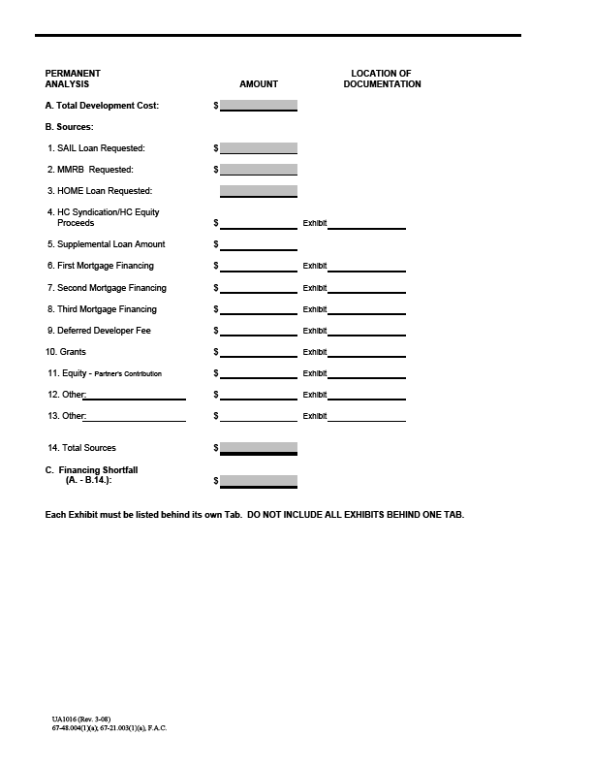
FINANCING AND PROPOSED STRUCTURE

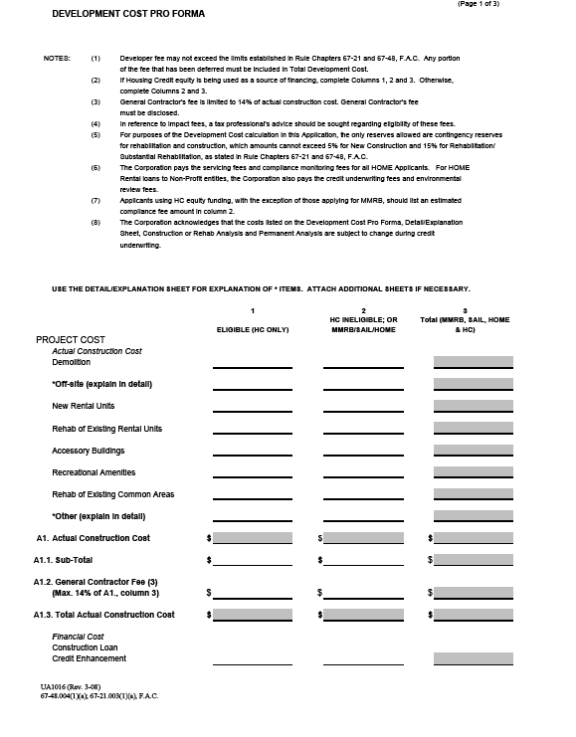

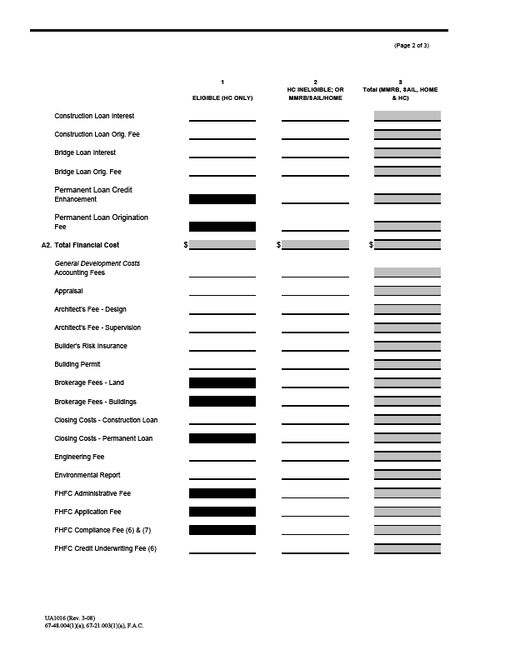
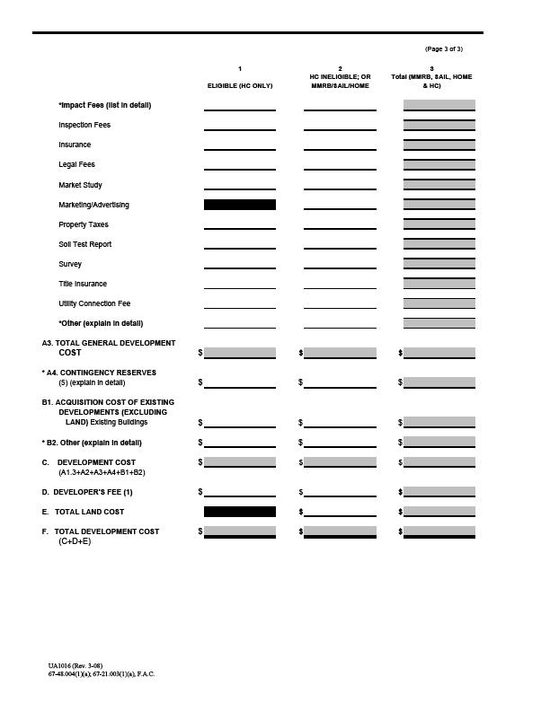

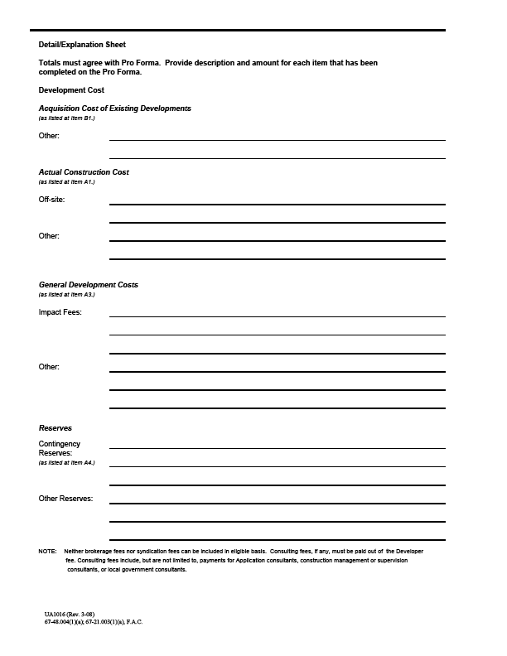

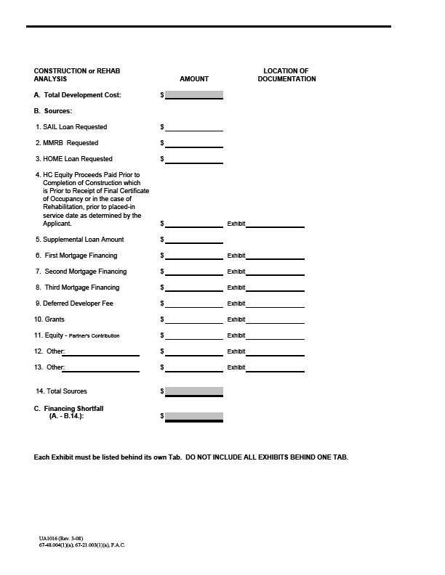

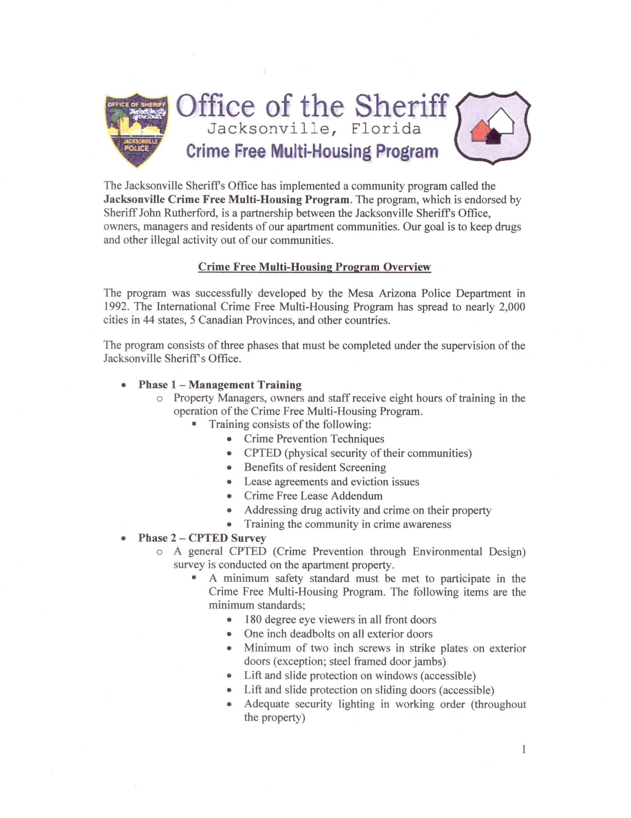
ATTACHMENT 2
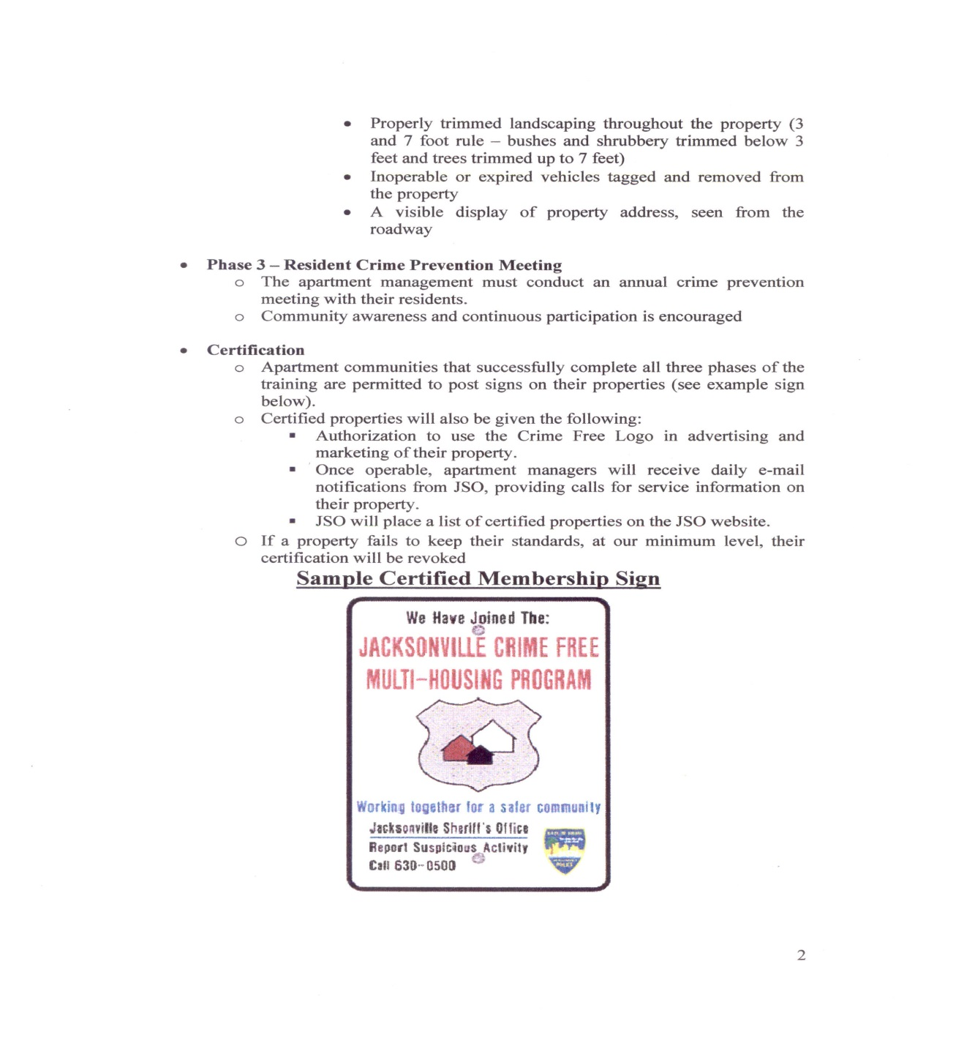

Attachment 3

EXPENSE AND INDEMNITY AGREEMENT
Jacksonville Housing Finance Authority
214 N. Hogan Street, 8th Floor
Jacksonville, FL 32202
Ladies and Gentlemen:
The undersigned (the "Applicant") has requested the Jacksonville Housing Finance Authority, Florida (the "Authority"), to consider its application for the issuance of the Bonds referred to below (the "Bonds") for the benefits of the Applicant and as an inducement to such consideration hereby agrees with the Authority as follows:
Section 1: Payment of Expenses. Whether or not the Bonds are offered, sold or issued, the Applicant agrees to pay and be liable for, and to hold the Authority harmless against the payment of any and all expenses relating to the Bond issue, including, without limitation, administrative charges and out-of-pocket expenses, recording charges, expenses of printing offering circulars or official statements, and the cost of printing the Bonds and advertising the sale thereof and expenses of registering the Bonds with the securities commission of any state. The fees of the Authority's bond counsel, financial advisor, administrative staff, and Issuer’s counsel shall be payable only if the Bonds are issued and delivered, but the Applicant shall in all events be liable for the payment of the disbursements and out-of-pocket expenses of such personnel. It is further agreed that the applicant fee is a separate fee, which shall not be used for the payment of the expenses delineated herein.
Section 2. Indemnity. Whether or not the Bonds are offered, sold or issued, the Applicant agrees to indemnify the Authority, and each of its members, officers, agents, attorneys or employees against any and all claims and liability of whatsoever nature arising out of the Bond issue, including without limitation, claims based upon actual or alleged misrepresentation, fraud or other tortious conduct or breach of contractual relationships, whether predicated upon federal or state statutes, common law, principles of equity or otherwise, excepting only claims based upon willful misfeasance or nonfeasance. In furtherance of the foregoing the Applicant agrees to pay any and all attorney's fees and court costs incurred in the defense of any of the claims here above enumerated upon the Authority's written demand thereof. It is further understood and agreed that the Authority or any of the persons here above indemnified shall be entitled to retain counsel acceptable to the Authority or them to defend any claim, but that neither the Authority nor any such person will enter into any settlement of the same without the prior written approval of the Applicant. It is further understood that the Authority will give reasonable notice to the Applicant of the pendency of any such claims or liability and the Applicant shall have the opportunity to recommend counsel for selection by the Authority or its members. The actual selection of counsel, however, will be solely within the discretion of the Authority or its members.
Section 3. Survival of Agreement. This Agreement shall survive the closing of the Bond issue and shall not merge into or be superseded by any other agreement other than by a written amendment hereto specifically denominated as such and executed by the Authority and the Applicant.
Dated: _____________ Name of Applicant:________________________
By: ________________ Title: __________________________________
Description of Bond:_________________________________________________________________
Jacksonville Housing Finance Authority (Florida)

By:_______________________________

